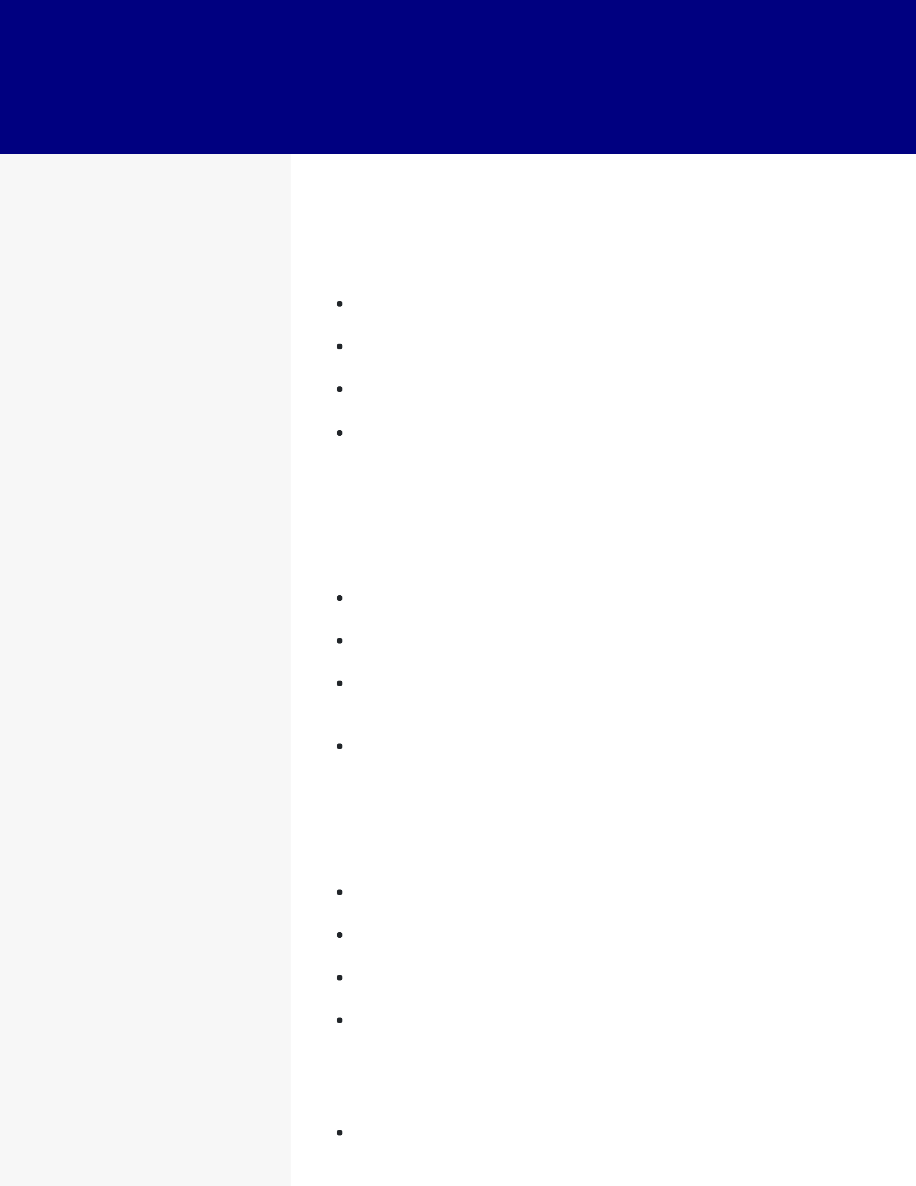GABRIEL TURNER

*AWS DATA ENGINEER*

**CONTACT**

g.turner@email.com 

1. 456-7890  Atlanta, GA  LinkedIn 

**EDUCATION**

Master of Science

Computer Science

Georgia Institute of

Technology

2015 - 2017

Atlanta, GA

Bachelor of Science

Computer Science

Georgia Institute of

Technology

2009 - 2013

Atlanta, GA

**SKILLS**

AWS Lambda

Presto

Teradata

Apache Airfow

Apache Kafka

PostgreSQL

Looker

GitHub

Terraform

**WORK EXPERIENCE**

AWS Data Engineer

Equifax

2019 - current / Atlanta, GA

Automated infrastructure management with Terraform, reducing deployment time by 51% in the AWS environment.

Analyzed data using Looker to proactively identify anomalies and limit discrepancies by 26%.

Developed CI/CD pipelines using GitHub, increasing development effciency by 34% through automated testing.

Designed AWS Data Pipeline workfows for effcient extraction, transformation, and loading, which **reduced data processing time by 42%**.

Database Administrator

The Home Depot

2016 - 2019 / Atlanta, GA

Implemented database replication for high availability, **achieving a 99.1% uptime for database systems**.

Managed database capacity planning to avoid performance bottlenecks and meet business needs 43% faster.

Conducted regular database backups and disaster recovery strategies to minimize data loss in the event of system failures, achieving a recovery point objective of under 1 hour.

Trained junior database administrators, fostering their growth and contributing to the overall team's knowledge.

Data Analyst

Cox Communications

2013 - 2016 / Atlanta, GA

Used AWS Lambda functions to automate data processing and reduce manual effort for 34% improved effciency.

Leveraged Apache Kafka for real-time data integration, **reducing data latency by 52% for business applications**.

Collaborated with cross-functional teams to deliver data solutions that met critical business requirements.

Monitored system performance with alerting mechanisms, reducing system downtime by 27%.

**CERTIFICATIONS**

AWS Certifed Big Data - Specialty